IFG Challenge 2nd Year

Three Week Programme Go Karting,BMX, Luge,

& Quad Bikes Physical

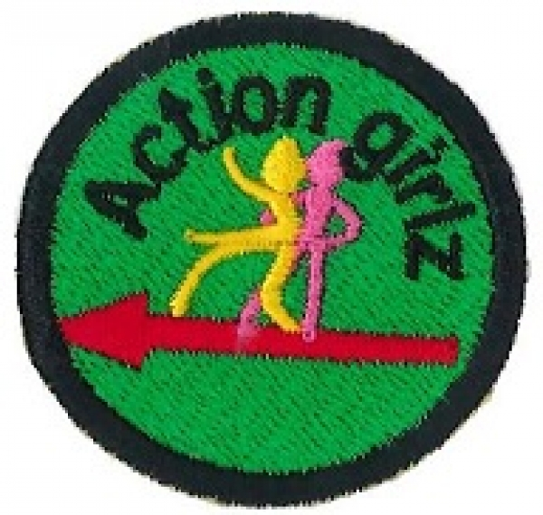
On completion of this three week programme the girls will have earned their Action badge.
As this programme is offered in each of the three years that a girl is in IFG Challenge, and this is the Second Year of the programme, please choose a different topic to last year.

Aim:
To teach the girls the skills required to safely take part in the recreational pursuits of Go Karting, BMX riding, Luge-ing and/or Quad Bike

Objectives:
- To have the girls learn about Go Karting, BMX riding, Lugeing and/or Quad Bike riding and all equipment necessary for the chosen pursuit.
- To instruct girls how to use any of these vehicles safely

Preparation:
- Organise this subject with the help of recognised and suitably qualified instructors’ e.g. relevant clubs in your area.
- Girls in the Challenge age are likely to be thrill seekers so it is imperative that the right personal are chosen to instruct and oversee any of these activities.
- Notice to parents about the activity, place of activity and clothing required.
- RAMS form – do not forget to complete your RAMS form for these activities.

Teaching Points:
Instruction should cover:
- Equipment –
- Maintenance of Equipment
- Instruction - How to use the vehicle
- Safety – Using the vehicle
- Road or track conditions
- Clothing

SetUp:
As this subject will be taken away from your usual meeting place, ensure that you have your master roll book with you.
Mark the roll before you commence the programme.

Devotion:
Depending on the circumstances you may just wish to open and close the session with a prayer instead of taking a full devotion.

Teaching Session/Activity:
Week One:
The girls will be instructed in the theory of Go Karting, BMX riding, Luging or Quad Bike riding including maintenance of equipment, instruction on how to use the vehicle, safety precautions, clothing etc. before attempting the practical.

Coach’s Tip:
It is most important that the girls have a tryout of the chosen pursuit during the first session.

Weeks Two and Three:
Build on what was learned in the first week.

Notices & home time:

